**Tic-Tac-Toe**

**1. Introduction:**

Tic-tac-toe  also known as noughts and crosses is a game for two players X and O, who take turns marking the spaces in a 3×3 grid. The player who succeeds in placing three of their marks in a horizontal, vertical, or diagonal row wins the game. The best play from both parties leads to a draw. Strategy , tactics, observation are the most important skills required for this game. It is straightforward to write a computer program to play tic-tac-toe perfectly, to enumerate the 765 essentially different positions.

**2. Design:**

Tkinter module is used for the project which is a standard Python interface to the Tk GUI toolkit. Tkinter is excellent for small, quick GUI applications. As Tkinter is a standard GUI for python applications, we can find a large number of resources in Standard Python Documentation. The official Tkinter documentation can be found at <https://docs.python.org/3.1/library/tkinter.html> Canvas widget was implemented in the project which uses the methods as follows:

2.1. create_oval( ) :

The method create_oval(coords,options) is used to draw an oval. Circle can be shown as a special type of oval to create ‘O’ as shown in figure 2.1.1

2.2. create_line( ):

The method create_line(coords, options) is used to draw a straight line. The coordinates "coords" are given as four integer numbers: x1, y1, x2, and the line goes from the point (x1, y1) to the point (x2, y2 ). It is used to create ‘X’ as shown in figure 2.2.1.

2.3. create_text( ):

The method create_text(x,y,options) can be applied to a canvas object to write text on it. The first two parameters, x and the y, are the positions of the text object. It’s used to display the text as in figure 2.3.1.



**Figure 2.1.1 Figure 2.2.1 Figure 2.3.1**

**3. Execution:**

The game starts with the title screen as shown in figure 3.1.

As the game continues further the two players X and O take turns marking the spaces in a 3×3 grid as shown in the figures from 3.2 to 3.8.

The figure 3.9 shows the intermediate screen which shows a line over the winning consecutive symbol.

The figure 3.10 shows the win screen where the player X won the match.

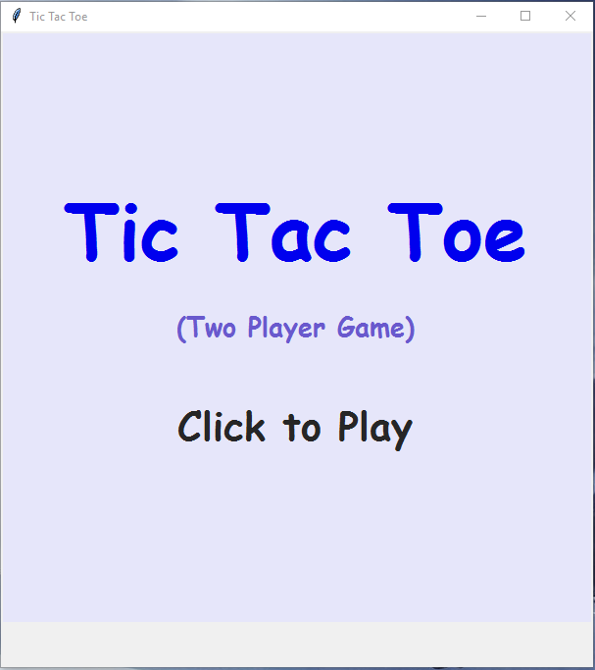 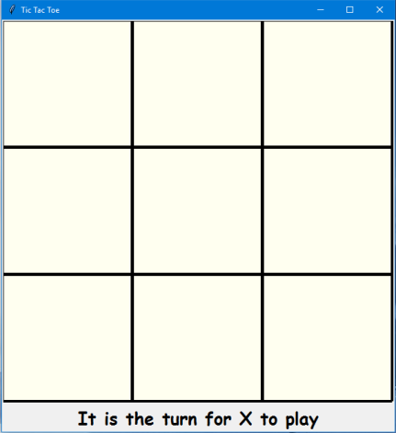 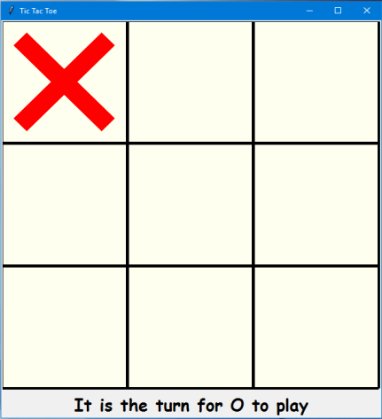

**Figure 3.1 Figure 3.2 Figure 3.3**

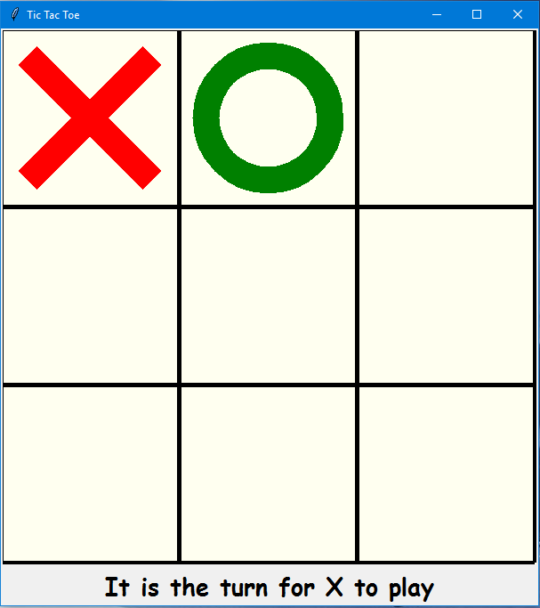 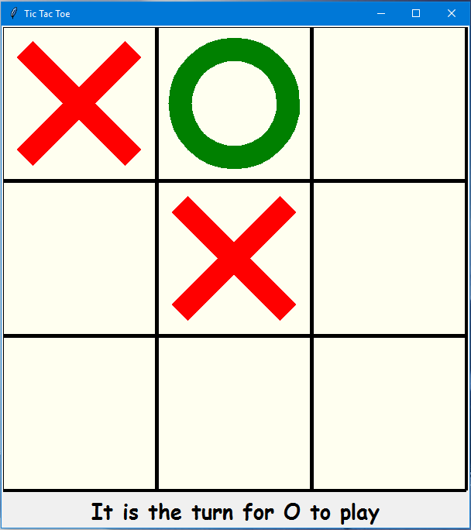 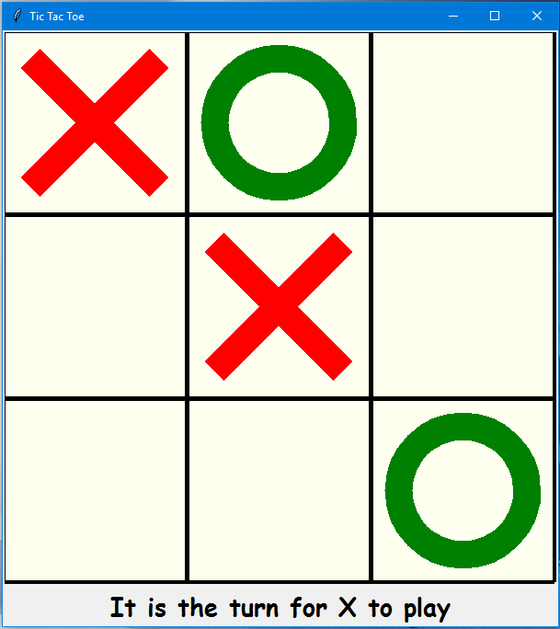

**Figure 3.4 Figure 3.5 Figure 3.6**

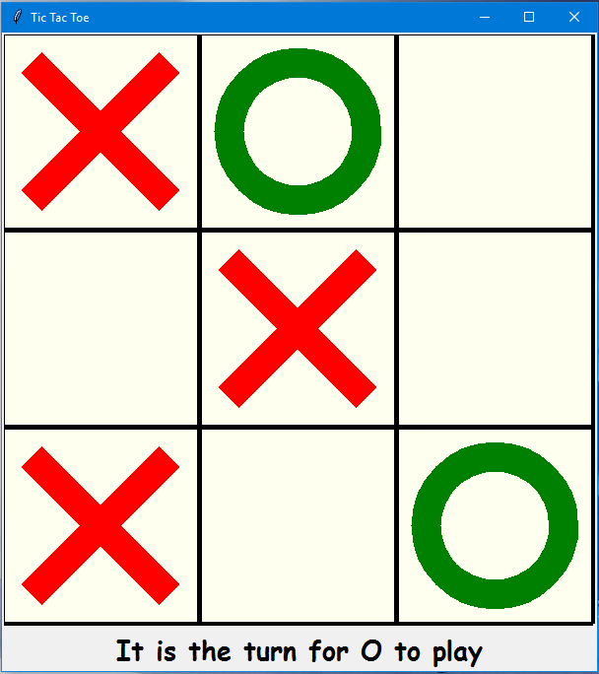 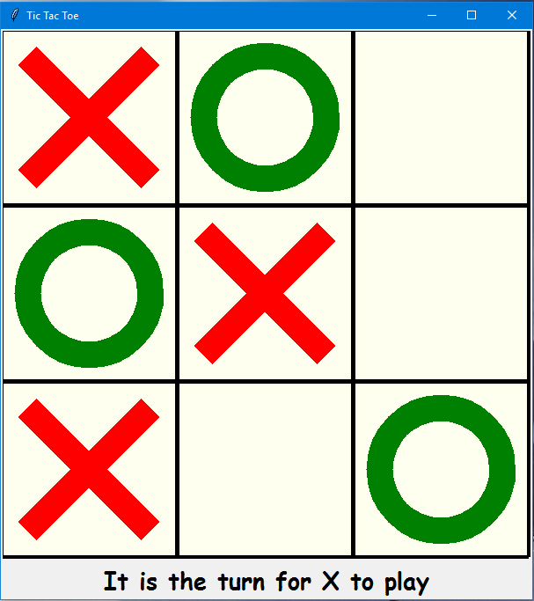 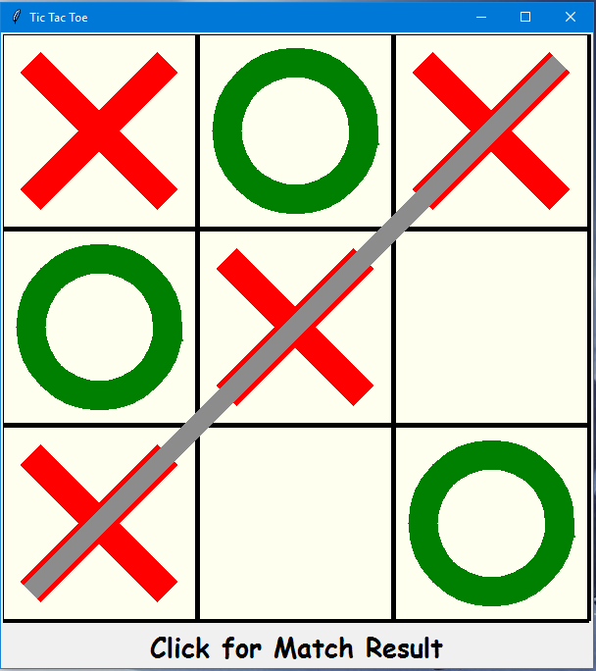

**Figure 3.7 Figure 3.8 Figure 3.9**

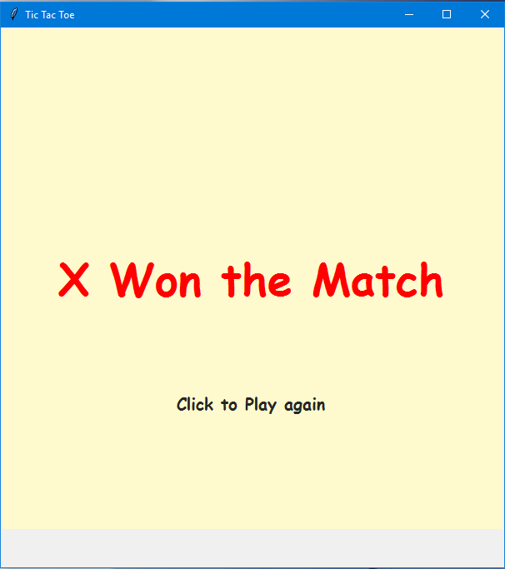

**Figure 3.10**

**4. Future Scope:**

The Tic-Tac-Toe game can be further improved by using the concept of artificial intelligence for a single player game in case a second player is not present. Because of the simplicity of tic-tac-toe is often used as a tool for teaching the concepts of good sportsmanship and the branch of artificial intelligence that deals with the searching of game trees.

This project can be found on GitHub – <https://github.com/ViditSave/Tic-Tac-Toe>